BASIC ELECTRONICS LABORATORY
(ECEN1011)


Syllabus:
EXPERIMENT NO | EXPERIMENT NAME | PAGE NO
1 | Familiarization with Electronic components | 3
2 | Familiarization with different measuring and testing instrument used in electronic laboratory | 12
3 | Study of VI Characteristics of PN Junction diode & Zener diode | 22
4 | - Study of the rectification characteristics of  Half wave rectifier  Full wave rectifier | 27
5 | Study On Characteristics  Of Bipolar Junction Transistor  In Common Emitter Configuration | 31
6 | Study on Characteristics  Of Bipolar Junction Transistor  in common base configuration | 38
7 | Study on characteristics of  Junction Field Effect Transistor | 44
8 | Application of Operational Amplifier | 49
9 | Application of Sub tractor, Integrator and Differentiator | 53
10 | Determination Of Common Mode Rejection  Ratio, Bandwidth And Slew Rate Of An Operational Amplifier | 58

EXPERIMENT 1 – Familiarization with Electronic components

OBJECTIVE:
- Study of different electronic components

EQUIPMENT & COMPONENTS:
- Power supply
- A voltmeter
- Connecting wires
- Resistance and Capacitors
- Bread Board
- Diode (IN4007)
  - Zener diode
  - LED

THEORY:
RESISTOR

The resistor’s function is to reduce the flow of electric current. This symbol 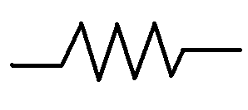 is used to indicate a resistor in a circuit diagram, known as a schematic. Resistance value is designated in units called the “Ohm”.
The resistance value of the resistor is not the only thing to consider when selecting the resistor for use in a circuit. The “tolerance” and the electric power ratings of the resistor are also important. Tolerance of a resistor denotes how close it is to the actual rated resistance value.
Power rating indicates how much power the resistor can safely tolerate.
There are two classes: 1. Fixed Resistors 2. Variable Resistors

Fixed Resistor
A fixed resistor is one in which the value of its resistance cannot change.

Carbon film resistors: -
This is the most general purpose, cheap resistor. It has a disadvantage, they tends to be electrically noisy. Metal film resistors are recommended for use in analog circuit. The physical size of the different resistors is as follows.
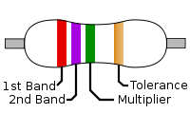

Variable Resistor
A variable resistor is one in which the value of its resistance can be change.
There are two ways in which variable resistors are used. One is the variable resistor which value is easily changed, like the volume adjusted of radio, the other is semi-fixed resistor are used to compensate for the inaccuracies of the resistors, and to fine-tune the circuit.
The rotation range of the variable resistor is usually about 300 degrees
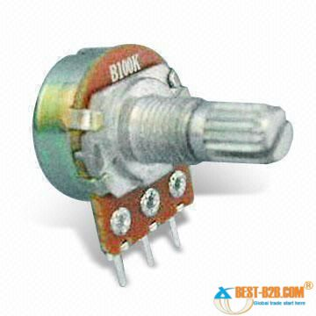
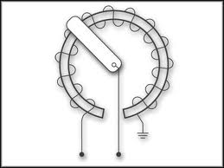

Wire wound resistors:-
Wire wound resistors, which are used in electronic equipments and instruments where high precision and more power dissipation are specified. Wire Wound Resistors are preferred over metal oxide resistors because of being better temperature co-efficient and of smaller size. Again wire wound resistors can be divided into silicon coated ceramic type, aluminium type etc., based on chemical composition and type of application.
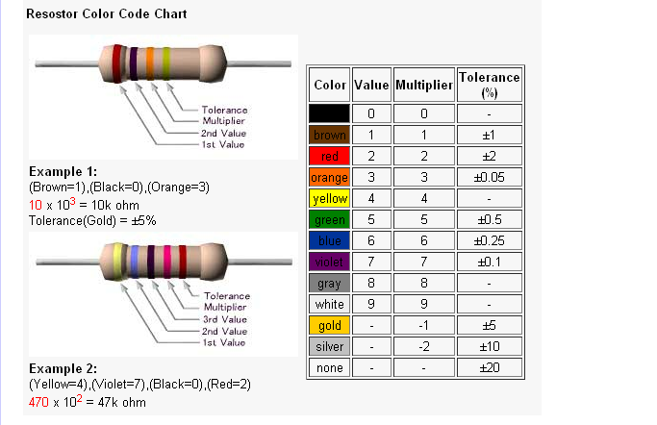
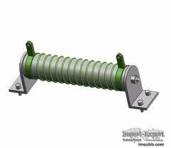

CAPACITOR
The capacitor’s function is to store electricity, or electric energy. It also acts as a filter, passing alternating current (AC), and blocking direct current (DC).
This symbol is 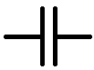 is used to indicate a capacitor in a circuit diagram. The value of a capacitor (the capacitance), is designated in units called the Farad (F).

Electrolytic Capacitors (Electrochemical type capacitors):-
Electrolytic capacitors have polarity; they have a positive and a negative electrode (Polarised). This means that it is very important which way round they are connected if they are connected in an incorrect polarity, it may burst.
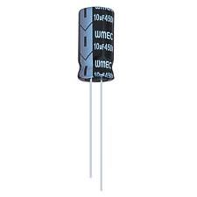

Ceramic Capacitors:-
Ceramic capacitors are comparatively small in size and have the shape of a disk. These capacitor can be used in high frequency application as internally they are not constructed as a coil. It should not be used for analog circuits, because they can distort the signal.
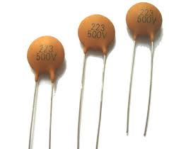

INDUCTOR
A coil wounded on a core or former of suitable material is called an inductor. In inductors voltage required a directly proportional to the rate of change of Current.
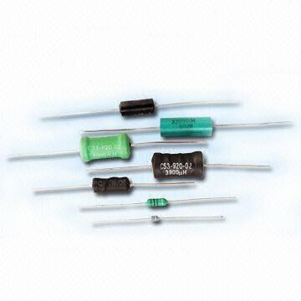

DIODE
The diode is a device formed from a junction of n-type and p-type semiconductor material. The lead connected to the p-type material is called the anode and the lead connected to the n-type material is the cathode. In general the cathode of a diode is marked by a solid line on the diode. Physically a diode is recognized by IN number such as IN4007.
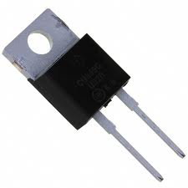
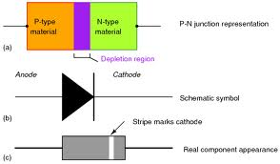

ZENER DIODE
The zener diode or reference diode, whose symbol is shown which finds primary usage as a voltage regulator or reference. The forward conduction characteristic of a zener diode is much the same as that of a rectifier diode; however it usually operates with a reverse bias, for which its characteristic is radically different.
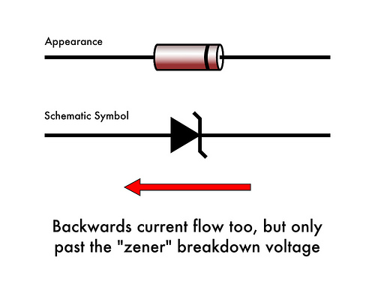

LED
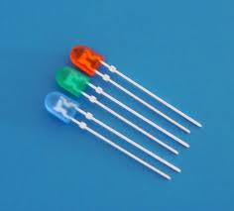

A light-emitting diode (LED) is a semiconductor light source. When a light-emitting diode is forward-biased (switched on), electrons are able to recombine with electron holes within the device, releasing energy in the form of photons. Light-emitting diodes are used in applications as diverse as aviation lighting, automotive lighting, advertising, general lighting, and traffic signals.

Transistors
The transistor has been derived from two words, “trans” means transfer of signal “istor” same general family resistor, so we can say transistor simply transfer the resistance. Transistor is a three terminal device, when these three terminals are used in biasing arrangement they form two p-n junctions, one junction is called emitter base junction and other is called collector base junction.
The transistor transfers the signal from low resistance to high resistance.
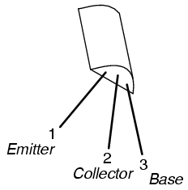
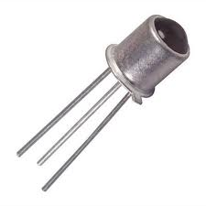

Bipolar Junction Transistor (BJT):-
It is a three terminal component, which is constructed with three doped semiconductor regions separated by two p-n junctions; the three regions are Emitter (E), Base (B) and Collector (C). There are two types of BJT, they are a) NPN and b) PNP.
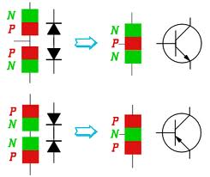

Field Effect Transistor (FET):-
The field-effect transistor (FET) is a transistor that uses an electric field to control the shape and hence the conductivity of a channel of one type of charge carrier in a semiconductor material. FETs are sometimes called uni-polar transistors to contrast their single-carrier-type operation

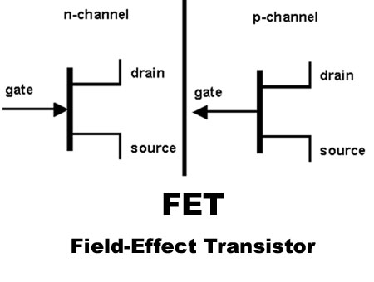

Integrated Circuits (ICs)
An Integrated circuit is a complete electronic circuit in which both the active and passive components are fabricated on an extremely tiny single chip of silicon.
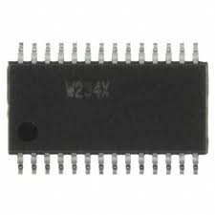

OBSERVATION TABLE:

- Table for the measurement of different resistance with color code

SL  NOS | PRACTICAL VALUE | THEORITICAL VALUE
1.
2.
3.
4.
5.

- Table for the measurement of different type of capacitors
SL  NOS | PRACTICAL VALUE | THEORITICAL VALUE
1.
2.
3.
4.
5.

Name of the component | Specification | Symbol | Physical Diagram | Calculated  Value | Measured  Value

CONCLUSION:

EXPERIMENT 2— Familiarization with different measuring and testing instrument used in electronic laboratory.

OBJECTIVE: Study of measuring and testing different instrument

THEORY:
POWER SUPPLY
Precautions:-
- Connect the input terminal of the power supply unit with ac main in proper way.
- Knobs should be rotated slowly.
- For small change of output use fine knob.
- Power ON switch must be off when the device is not in use.
- The location should be free from dust & humidity.
- Do not operate the instrument where mechanical vibrations are excessive or near an instrument, which generated strong electric or magnetic field.

For the operation of most of the devices in electronic equipment, a dc voltage is required. Usually this supply is provided by the battery but maintenance of battery is not easy so we use a battery eliminator in the place of battery. The equipment, which converts ac voltage of main supply into dc voltage, called DC power supply.
There are two types of DC power supply:-
1. Unregulated power supply
2. Regulated power supply.
Variable DC Regulated Power Supply:-
A regulated power supply is an embedded circuit, or stand alone unit, the function of which is to supply a stable voltage (or less often current), to a circuit or device that must be operated within certain power supply limits. The output from the regulated power supply may be alternating or unidirectional, but is nearly always DC.
Regulated DC power supply:-
DC regulated power supply is a source of DC power input so that we can vary the output voltage of the power supply. DC regulated power supply consists power transformer, rectifier, filter, regulator

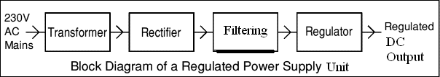

INSTRUCTION:
Before switching ON the unit, observe that no load is connected across the output terminals. Now plug the unit into a three pin wall socket giving
230-V AC 50 Hz main supply and switch ON the unit.
SETTING THE VOLTAGE AND CURRENT LIMITS:
The power supply gives a constant voltage output with automatic crossover characteristics. For setting the output voltage, adjust the “VOLTAGE COARSE &
FINE” control until the panel voltmeter reads the desired voltage, this voltage
Becomes the voltage limit of the supply.
For setting the current limit short circuit the output terminals on the front panel and adjust the CURRENT COARSE & FINE, controls until the panel meter reads the desired current this current becomes the current limit of the supply. Now remove the short circuit.
MULTIMETER
Precautions:-
- The function selector switch should be kept in the voltage selection while meter is not in used.
- Zero adjustment for each range should be made before taking a measurement with ohmmeter (for analog multimeter)
- When the meter is linked to a measurement circuit, do not touch unused terminals.
- When the value to be measured is unknown, set the range selector switch at the highest position.
- Before rotating the selector switch to change functions, disconnect test leads from the circuit under test.
- Never perform resistance measurements on live circuit.
- Always be careful when working with voltages. Keep fingers behinds the probe barriers while measuring.
- Before attempting to insert transistors for testing always be sure that the test leads have been disconnected from any measurement circuit.
- Replace the battery when its voltage falls due to long use of the ohmmeter.

Multimeter, is a measuring instrument, which is used to measure many (multi) electrical entities. A simple multi meter can measure voltage (ac and dc), current (ac and dc) and resistances. A multi meter consists of an ammeter, voltmeter and ohmmeter combined, with a function switch to connect the appropriate circuit.
There is another switch, called the range switch, which is used to fix a range of measurements.

There are two type of Multimeter:-
- Analog multi meter.
- Digital multi meter.

Digital Multi meter:-
The digital multimeter (DMM) is a versatile and accurate instrument. In which the result of measurement is displayed in discrete intervals or numerals. Although, DMM are expensive and complicated then analog meter but if offers high accuracy, have high input impedance and smaller in size than analog meter.
A basic digital multimeter is made up of several A/D converters, circuitry for counting and an attenuation circuit.
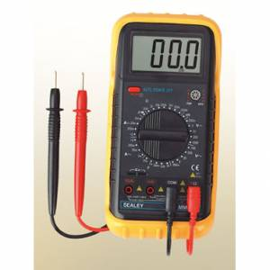

CATHODE RAY OSCILLOSCOPE
(CRO)
Precautions:-
- Select a location free from high temperature, humidity and dust.
- Do not operate the CRO in a place where mechanical vibration are excessive or a place where strong magnetic fields are present.
- Connect the input terminal of Function Generator unit with the AC main in proper way.
- Do not increase the brightness of the Cathode Ray Tube more than is needed.
e) Switch off the mains of the unit when it is not in used.
f) BNC should be connected to the output terminal of Function Generator in a proper way.

The cathode ray oscilloscope (CRO) is a versatile laboratory instrument used for the visual observation, measurement and analysis of waveforms. Basically a CRO is a very fast X-Y plotter that shows an input signal versus another signal or versus time. CRO depends on the movement of an electron beam, which is then made visible by allowing the beam to impinge on a phosphor surface, which produces a visible spot.
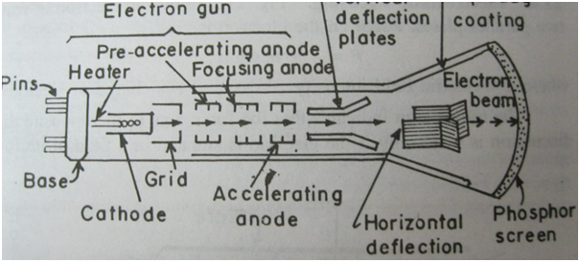

Oscilloscope block diagram:-
The heart of the oscilloscope is the cathode ray tube (CRT). Which generates the electrons beam, accelerates the beam to a high velocity deflect the beam to create image of input signals and contains the phosphor screen where the electron beam eventually becomes visible. The rest part of the CRO consists of circuitry to operate the CRT.
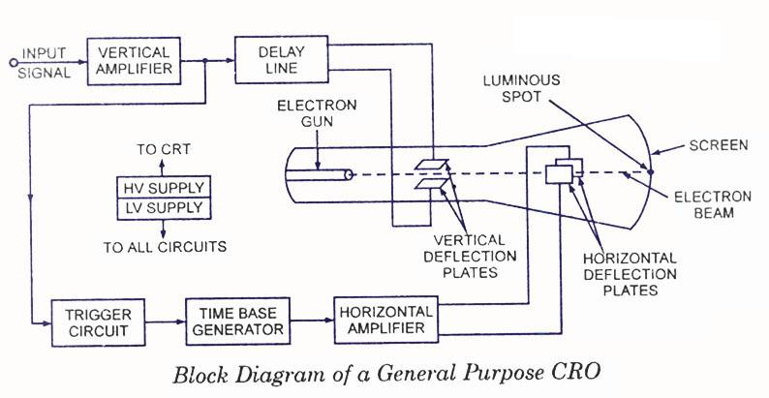

Oscilloscope has a time base generator, which generates the saw tooth voltage to supply the CRT to deflect the spot at a constant time dependent rate. The signal to be viewed is fed to calibrate gain vertical amplifier, which increases the potential of the input beam. To synchronize the horizontal deflection with the vertical input, such that the horizontal deflection starts at the same point of the input vertical signal each time it sweeps, a synchronizing or triggering circuit is used. The power supply block provides the voltage required by the CRT to generate and accelerates the electrons beam, as well as to supply the required operating voltage (not more than few hundred) for other circuits of the oscilloscope.
CRT:
The main components of a general purpose CRT are
- Electron Gun consisting cathode, focusing and accelerating electrodes.
- Deflecting system.
- Fluorescent Screen.

Electron Gun
It produces sharply focused beam of electrons, accelerated to a high velocity. It consists of an indirectly heated cathode, a control grid, an accelerating electrode, a focusing anode and a final accelerating anode. These electrodes have a cylindrical shape and they are connected to the pins on the base. The cathode emitting the electron is completely surrounded by a control grid consisting of a nickel cylinder with a small hole at the centre. The electrons that manage to pass through this hole constitute the electron beam; the brightness of the spot on the face of the screen depends upon the beam intensity. It can be controlled by changing the negative bias on the control grid.
A high positive voltage is applied to the accelerating electrode with respect to the cathode. The accelerating electrode thus speeds up the electron beam passing through it. These electrons, being negatively charged, have a tendency to diverge from each other. So to focus the electron beam into a tiny spot on the screen, there is a focusing anode which forms an electron optical system with the help of accelerating and the final accelerating anode. The focusing anode is given a slightly lower potential than the accelerating anodes. Because of the difference in potentials the equipotent surfaces between the two cylinders (focusing anodes and accelerating anodes) from a shape like a convex lens, when the electron beam passes through this region the electrons experience a focus in a direction normal to the equipotent surfaces. As a result the beam is converged to a point on the screen. Usually the accelerating anodes voltage is kept fixed and by changing the potential of the focusing anode, we can change the focal length of the electrostatic lens and focusing is achieved.

Deflecting System
Vertical deflection system:-
It provides amplified, signal of the proper level to derive the vertical plates without introducing any appreciable distortion into the system.
The block diagram of the vertical deflection system shows that the input connector feeds an input attenuator, after which follows the vertical amplifier. There is a switch able input coupling capacitor in the block diagram, which connects attenuator with input signal. Coupling capacitor is provided so that measurement of ac signals may be viewed in the presence of high dc voltage. When dc measurements are to be made, the capacitor may be removed using ac/dc switch.
Delay Line:
All electronic circuitry in the oscilloscope (attenuator, amplifier, pulse generator) causes a certain amount of time delay in the transmission of signal voltage to the deflection plates. To allow the operator to observe the leading edge of the signal waveform, the signal drive for vertical deflection must be therefore delayed by at least the same amount of time required by the horizontal deflection system. For this reason vertical delay line is used in between vertical amplifier vertical deflecting plates of CRT.
Horizontal Deflection System:-
The horizontal deflection system consists of a time bead generator, a trigger circuit and a horizontal amplifier.
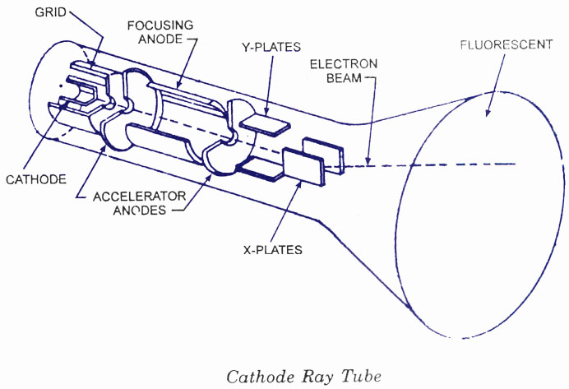

Function Generator
A function generator is usually a piece of electronic test equipment or software used to generate different types of electrical waveforms over a wide range of frequencies. Some of the most common waveforms produced by the function generator are the sine, square, triangular and saw tooth shapes. Function generators cover both audio and RF frequencies, they are usually not suitable for applications that need low distortion or stable frequency signals. When those traits are required, other signal generators would be more appropriate.

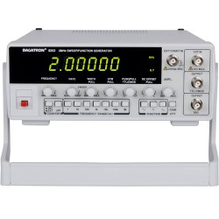

Function Generator

EQUIPMENTS:
- Power Supply
- Multi meter
- CRO
- Function Generator

EXPERIMENTAL RESULTS:
TABLE-01
Measurement of DC voltage in CRO
SL NO | OUTPUT OF DC  POWER SUPPLY | SENSITIVITY (D)  {VOLT/DIV} | DEFLECTION OF LINE ON SCREEN OF CRO | DC VOLTAGE  (AXD)
TABLE-02
Measurement of AC voltage in CRO
SL NO | TYPE OF  SIGNAL | VOLTAGE SENSITIVITY  (D) OF CRO {VOLT/DIV} | PEAK-PEAK  DSTANCE OF  THE APPLIED  SIGNAL ON  CRO SCREEN  (A) DIV | PEAK-PEAK  VOLTAGE  OF APPLIED  SIGNAL  (AXD) VOLT | AMPLITUDE  OF THE SIGNAL  (AXD)/2VOLT

TABLE-03
Measurement of frequency of AC signal using CRO
SL NO | FREQUENCY READ  FROM F.G | SENSITIVITY OF  TIME BASE OF  CRO IN SEC | TIME PERIOD  OF SIGNAL IN  SEC | FREQUENCY OF  APPLIED SIGNAL  IN Hz | DISPLAY OF WAVEFORM ON  CRO

TABLE-04
Measurement of DC voltage using digital multi meter
SL NO | DC VOLTAGE READ  FROM POWER  SUPPLY IN VOLT | SELECT RANGE  OF DMM | DISPLAY OF VOLTAGE ON  DMM IN mv OR VOLT

TABLE-05
Measurement of R.M.S Voltage of a sinusoidal
SL NO | FREQ OF SIGNAL (HZ) | SELECT RANGE  OF DMM (V/DIV) | DISPLAY OF  VOLTAGE ON  DMM | CALCULATED VOLTAGE FROM  CRO  (rms value=amplitude  X0.707)

CONCLUSION:

EXPERIMENT 3: Study of VI Characteristics of PN Junction diode & Zener diode

OBJECTIVE:
- Study of VI characteristics of junction diode.
- Determine the cut-in voltage.

THEORY:
The diode is a device formed from a junction of n-type and p-type semiconductor material. The lead connected to the p-type material is called the anode and the lead connected to the n-type material is the cathode. In general the cathode of the diode is marked by a solid line on the diode.
The primary function of the diode is the rectification. When it is a forward bias (the higher potential is connected to the anode lead), it will pass current. When it is reverse bias (the higher potential is connected to the cathode lead), the current is blocked.

The characteristic curve of an ideal diode and a real diode are shown in the figure. For silicon diode, the typical forward voltage is 0.7 volts, nominal. For germanium diodes the forward voltage is only 0.3 volts.
For most simplified circuit analysis, the voltage drop across a conducting diode may be considered constant at the nominal figure and not related to the amount of current. Actually, the forward voltage drop is more complex. An equation describes the exact current through a diode, given the voltage dropped across the junction, the temperature of the junction, and the several physical constants. It is commonly known as the diode equation.

Shockley diode equation
The Shockley ideal diode equation or the diode law (named after transistor co-inventor William Bradford Shockley, not to be confused with tetrode inventor Walter H. Shockley) is the I-V characteristic of an ideal diode in either forward or reverse bias (or no bias). The equation is :-

Where,
I is the diode current,
I_{S} is the reverse bias saturation current (or scale current),
V_{D} is the voltage across the diode,
V_{T} is the thermal voltage, and n is the ideality factor, also known as the quality factor or sometimes emission coefficient.

The thermal voltage V_{T} is approximately 25.85 mV at 300 K, a temperature close to "room temperature" commonly used in device simulation software. At any temperature it is a known constant defined by:
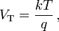
Where,
q is the magnitude of the charge on an electron (the elementary charge)
k is Boltzmann’s constant
T is the absolute temperature of the p-q junction in Kelvin

Diode Resistance:
Different kind of resistance is better explained by a simple but common example, the diode. Shown below is a graph of (nonlinear) diode current as a function of diode voltage.

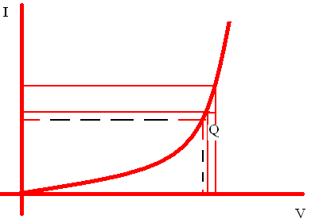
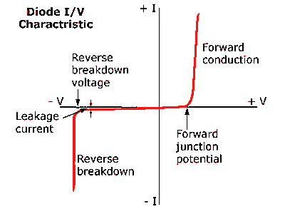

At the operating point Q, the static (dc) current and voltage are ‘I’ and ‘V’. Consequently, the total variable resistance is R=V/I. Because V and I are constant, R is also the static resistance of the diode at Q. For incremental (small-signal) variation around Q, a change in ‘V’ will produce a corresponding change in ‘I’. The resulting resistance is the incremental resistance:
Where, r is calculated at operating point Q. This incremental resistance is sometimes referred to as the dynamic resistance because it involves change in ‘V’ and ‘I’.

CIRCUIT DIAGRAM FOR P-N JUNCTION DIODE:
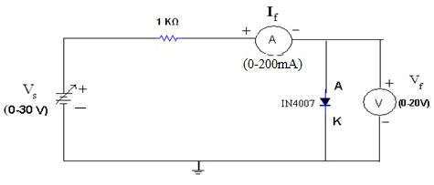

CIRCUIT DIAGRAM OF ZENER DIODE:

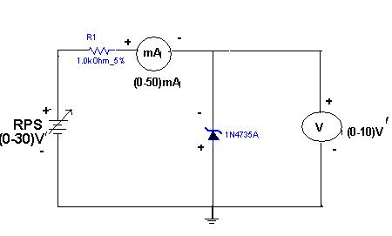

EQUIPMENTS:

- Power supply
- A voltmeter (range 30 v)
- A few connecting hard wires
- A multi-ammeter (range 20mA)
- A bread board
- A diode
- 10 KΏ resistor

PROCEDURE:
- Make the circuit as shown in the above figure.
- Set the meter indicated by “A” to 20 mA range. Set the meter “V” to read up 4v on the DC supply rotary voltage control fully anticlockwise (0V).
- Now switch ON the power supply and carefully turn the voltage control wise whilst watching the ammeter.
- Set the value of the voltage and observe the values of the current. Plot these values.
- On the graph paper. The resulting graph shows that the little current passes until the voltage has risen to 0.6V (for silicon), but the current rises rapidly with further increases voltage.
- Repeat all previous steps and fill the observation table.
- Finally plot the V-I characteristics of diode on graph paper.

OBSERVATION TABLE:
DIODE | FORWARD CHARACTERISTICS |  |  | REVERSE CHARACTERISTICS
SILICON DIODE | SL NOS | CURRENT | VOLTAGE | SL NOS | CURRENT | VOLTAGE
GERMANIUM DIODE
ZENER DIODE

CONCLUSION:

EXPERIMENT NO 4: STUDY OF HALF & FULL WAVE RECTIFIERS
OBJECTIVE: Study of the rectification characteristics of
Half wave rectifier
Full wave rectifier
To observe O/P wave forms with and without filter circuit
To calculate ripple factor from experimental data

THEORY:
A rectifier is a circuit that converts pulsating ac into pulsating. There are three basic type of rectifier circuits the half wave, full wave (centre tapped) and rectifiers. Of them, bridge rectifier is the most commonly used.

HALF WAVE RECTIFIER
Half wave rectification is a process, which converts an ac sinusoidal input voltage into a pulsating dc voltage with the output pulse occurring for each input cycle. The half wave rectifier conducts the current only during the positive half input cycle. The half wave rectifier is made up of single diode and resistor (load). The half wave rectifier conducts the current only during the positive cycle of the ac input supply. The negative half cycle of a c supply is suppressed i.e during the negative half cycle, no current is conducted and hence no voltage appears across the load. Therefore currents always flow in one direction (i.e d.c) through the load after every half cycle
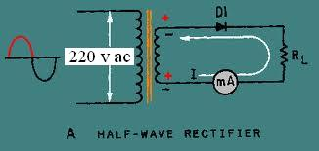
Operation:
The a.c voltage is applied across the secondary windings. During the positive half cycle of a.c input voltage point 5 is positive with respect to point 8. this make the diode upper half cycle.

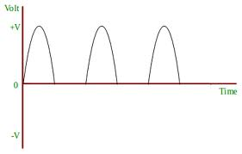

During the negative half cycle, point 5 is negative with respect to under the diode D1 is reverse bias and no current conducts as shown in figure the current flows through the diode during the positive half cycle. In this the current flows through the load always in same direction. Hence d.c output is obtained thus complete the output wave form of half wave rectifier of three cycle will look like as shown in the figure.
EQUIPMENTS:
- Centre tapped Transformer
- CRO
- A voltmeter (range 30 v)
- A few connecting wires
- A bread board
- Diode
- Capacitor
- 10 KΏ resistor

CIRCUIT DIAGRAM:
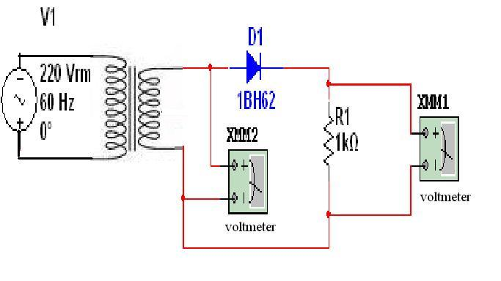

FULL WAVE RECTIFIER
Full wave rectification is the process through which an ac sinusoidal input voltage is converted into a pulsating dc voltage with two output pulses occurring for each input cycle. The full wave rectifier consists of two diodes and a load resistor.

Operation:-
During the positive half cycle of a.c input voltage, point 5 is positive and point 8 is negative. This make the diode D1 forward bias and D2 reverse bias.
Therefore D1 conducts the current and D2 does not conduct the current, so current will only flow across D1 through the load resistor in upper half cycle as shown in the figure. During the negative half cycle, of the a.c input voltage point 5 is negative and point 8 is positive. Under this condition the diode D2 is forward bias while diode D1 is reverse biased. Therefore D2 conducts the current because D2 is in forward biased condition while D1 does not conduct current because the D1 is in reverse bias condition.

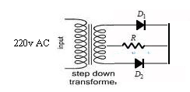

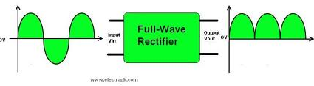

PROCEDURE:-
- Make the circuit diagram as shown in the figure above.
- Observe the rectifier output.
- Calculate the ripple factor.
- Observe the ripple on the oscilloscope, using the feature of dc/ac coupling

OBSERVATION TABLE:
TYPES OF  RECTIFIER |  | INPUT VOLTAGE | OUTPUT  VOLTAGE | O/P  V’rms | O/P  Vdc | RIPPLE  FACTOR
HALF WAVE | WITHOUT  FILTER
HALF WAVE | WITH  FILTER
FULL WAVE | WITHOUT  FILTER
FULL WAVE | WITH  FILTER

CONCLUSION:

EXPERIMENT NO 5: Study On Characteristics
Of Bipolar Junction Transistor
In Common Emitter Configuration

OBJECTIVE:-
To obtain input output characteristics of BJT in common Emitter configuration.
EQUIPMENTS & COMPONENTS:-
- Power cycle
- Voltmeter
- Multi ammeter
- Transistor (NPN)
- Resistance (82 kΏ)
- Some connecting wires
THEORY:-
When a transistor is operated in such a way that a emitter terminal is common in both the input and output circuits, the mode of operation is called the common emitter (CE) mode or the grounded emitter configuration of the transistor.
The plot of collector current I (C) against the collector –to-emitter voltage V(CE) with the base current I(B) as a parameter is known as the CE mode output characteristics of the transistor.
The portion of the output characteristics where the emitter junction is forward biased and the collector junction is reverse biased is termed the active region of the characteristics. In this region, I(B)>0 and V(CE)≥a few lengths of a volts. The ac current gain 8 (h(fe)) and the output admittance h(oe) for the CE mode are respectively given by.

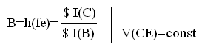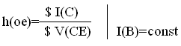

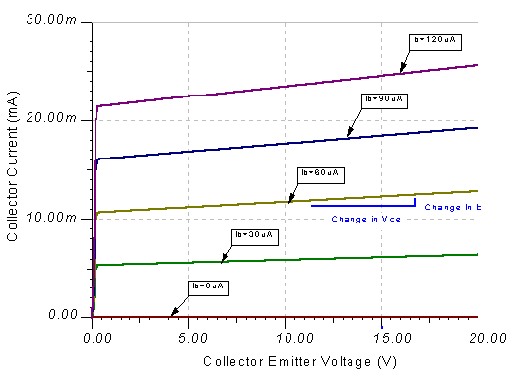

TRANSISTOR
Introduction:-
The transistor is a three layer (electrode) semiconductor device. Three electrodes are the emitter, the base and the collector. The emitter injects charge carriers into the base, which in controls the numbers these carriers that are eventually gathered by the collector.
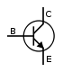
There are two types of semiconductors:-
1. NPN

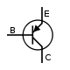

2. PNP
In both the types the emitter base junction is forward biased and the collector base junction is reverse biased.
When the transistor is used as the amplifier, the input voltage is given between two terminals and the output is taken from another pair of terminals, we have to make one of the terminals common to the input and the output terminals. The BJT can be used with any of its terminals as the common point. The resulting circuit configuration are: Common base (CB) , Common Emitter (CE) And Common Collector (CC).
The families of characteristics curves specify the transistor parameters in any of the configurations mentioned. One set the output characteristics gives the V-I relationship at the output terminals for different values of the input current.

Theory:-
The collector–emitter current can be viewed as being controlled by the base–emitter current (current control), or by the base–emitter voltage (voltage control). These views are related by the current–voltage relation of the base–emitter junction, which is just the usual exponential current–voltage curve of a p-n junction (diode).
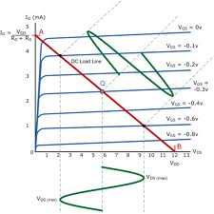

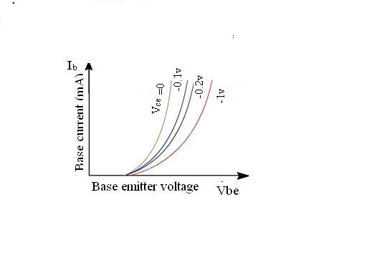
The physical explanation for collector current is the amount of minority carriers in the base region. Due to low level injection (in which there are much fewer excess carriers than normal majority carriers) the am bipolar diffusion rate (in which the excess majority and minority carriers flow at the same rate) is in effect determined by the excess minority carriers.

Bipolar transistors have five distinct regions of operation, defined by BJT junction biases
The modes of operation can be described in terms of the applied voltages (this description applies to NPN transistors; polarities are reversed for PNP transistors):
- Forward active: base higher than emitter, collector higher than base (in this mode the collector current is proportional to base current by ).
- Saturation: base higher than emitter, but collector is not higher than base.
- Cut-Off: base lower than emitter, but collector is higher than base. It means the transistor is not letting conventional current to go through collector to emitter.
- Reverse-active: base lower than emitter, collector lower than base: reverse conventional current goes through transistor.

CIRCUIT DIAGRAM:

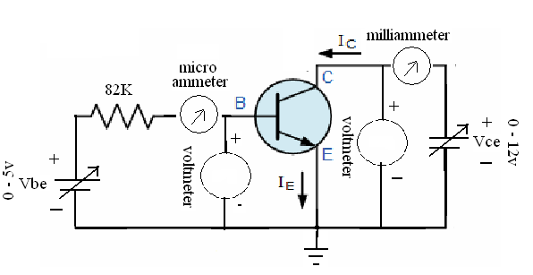

Working Procedure:-
- Connect the circuit as shown in the diagram.
- Turn two power supply knobs (Base supply and collector supply) at minimum position.
- Put ON the supply switch.
- For input characteristics.
This is the relationship between and 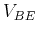 both associated with the input port:
Here
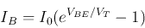
as the EB junction is essentially the same as a forward biased diode. Also, higher 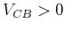 can slightly increase.
5.For output Characteristics:
This is the relationship between and 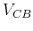 both associated with the output port:
When , i.e., the CB junction is reverse biased, the current depends totally on . When 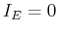, 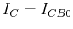 is the current caused by the minority carriers crossing the PN-junction. This is similar to the diode current-voltage characteristics seen before, except both axes are reversed (as both 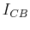 and are defined in the opposite directions). When is increased, 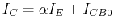is increased correspondingly. Higher can slightly increase .
As 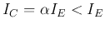, CB configuration does not have current-amplification effect. However, if is held constant, and therefore will also be held constant, i.e., CB transistor circuit can be used as a current source.

OBSERVATION:-
TABLE-01
Data for input characteristics
SL NOS | COMMON EMITTER VOLTAGE V_{CE} (V) | BASE EMITTER VOLTAGE . V_{BE} (V) | BASE CURRENT . I_{B} µA
1 | 2V
2 | 4V
3 | 6V
4 | 8V

TABLE-02
Data for output characteristics
SL NOS | BASE CURRENT I_{B} µA | COLLECTOR EMITTER VOLTAGE V_{CE} (V) | COLLECTOR CURRENT I_{C} (µA)
1 | 0 µA
2 | 10 µA
3 | 20 µA
4 | 30 µA

CONCLUSION:
EXPERIMENT NO 6: Study on Characteristics of Bipolar Junction Transistor in common base configuration

OBJECTIVE:
To obtain input output characteristics of BJT in Common Base configuration.

EQUIPMENTS & COMPONENTS:-
- Power cycle
- Voltmeter
- Multi ammeter
- Transistor (NPN)
- Resistance (1KΏ & 500Ώ)
- Some connecting wires

THEORY: TRANSISTOR

Introduction:-
The transistor is a three layer (electrode) semiconductor device. Three electrodes are the emitter, the base and the collector. The emitter injects charge carriers into the base, which in controls the numbers these carriers that are eventually gathered by the collector.
There are two types of semiconductors:-
1. NPN

2. PNP

In both the types the emitter base junction is forward biased and the collector base junction is reverse biased
When the transistor is used as the amplifier, the input voltage is given between two terminals and the output is taken from another pair of terminals, we have to make one of the terminals common to the input and the output terminals. The BJT can be used with any of its terminals
as the common point. The resulting circuit configuration are: Common base (CB) , Common Emitter (CE) And Common Collectot (CC).
The families of characteristics curves specify the transistor parameters in any of the configurations mentioned. One set the output characteristics gives the V-I relationship at the output terminals for different values of the input current.
Theory:-
In electronics, a common-base (also known as grounded-base) amplifier is one of three basic single-stage bipolar junction transistor (BJT) amplifier topologies, typically used as a current buffer or voltage amplifier. In this circuit the emitter terminal of the transistor serves as the input, the collector the output, and the base is common to both (for example, it may be tied to ground reference or a power supply rail), hence its name. The analogous field-effect transistor circuit is the common-gate amplifier.
This arrangement is not very common in low-frequency circuits, where it is usually employed for amplifiers that require unusually low input impedance, for example to act as a preamplifier for moving-coil microphones. However, it is popular in high-frequency amplifiers, for example for VHF and UHF, because its input capacitance does not suffer from the Miller effect, which degrades the bandwidth of the common-emitter configuration, and because of the relatively high isolation between the input and output. This high isolation means that there is little feedback from the output back to the input, leading to high stability.
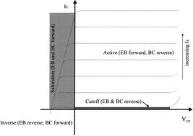

This configuration is also useful as a current buffer since it has a current gain of approximately unity (see formulas below). Often a common base is used in this manner, preceded by a common-emitter stage. The combination of these two forms the cascode configuration, which possesses several of the benefits of each configuration, such as high input impedance and isolation.
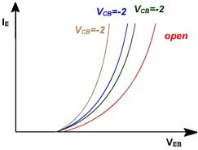

CHARACTERISTICS:-
The amplifier input impedance R_{in} looking into the emitter node is very low, given approximately by
,

Where V_{T} is the thermal voltage and I_{E} is the DC emitter current.
For example, for V_{T} = 26 mV and I_{E} = 10 mA, rather typical values, R_{in} = 2.6 Ω. If I_{E} is reduced to increase R_{in}, there are other consequences like lower transconductance, higher output resistance and lower β that also must be considered. A practical solution to this low-input-impedance problem is to place a common-emitter stage at the input to form a cascode amplifier.

- Because the input impedance is so low, most signal sources have larger source impedance than the common-base amplifier R_{in}. The consequence is that the source delivers a current to the input rather than a voltage, even if it is a voltage source. (According to Norton's theorem, this current is approximately i_{in} = v_{S} / R_{S}). If the output signal also is a current, the amplifier is a current buffer and delivers the same current as is input. If the output is taken as a voltage, the amplifier is a transresistance amplifier, and delivers a voltage dependent on the load impedance, for example v_{out} = i_{in} R_{L} for a resistor load R_{L} much smaller in value than the amplifier output resistance R_{out}. That is, the voltage gain in this case (explained in more detail below) is:
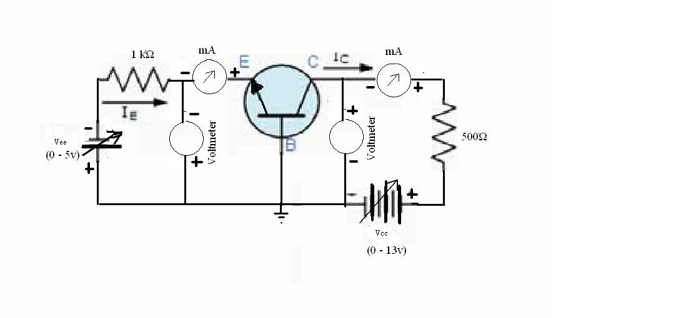
.

OBSERVATION:-
TABLE-01
DATA FOR INPUT CHARACTERISTICS
SL NOS | COMMON BASE VOLTAGE V_{CB (}V) | EMITTER BASE VOLTAGE V_{EB} (V) | EMITTER CURRENT I_{E (mA)}
1 | 0V
2 | -1V
3 | -2V
4 | -3V

TABLE-02
DATA FOR OUTPUT CHARACTERISTICS
SL NOS | EMITTER CURRENT I_{E (mA)} | COLLECTER BASE VOLTAGE V_{CB} VOLT | COLLECTOR CURRENT I_{C ( mA)}
1 | 10mA
2 | 20mA
3 | 30mA
4 | 40mA

CONCLUSION:

EXPERIMENT NO 7: Study on characteristics of
Junction Field Effect Transistor

OBJECTIVE:
To obtained the drains and transfer characteristics of FET
From the plotted curve obtain drain resistance. Amplification factor and mutual transconductance.

EQUIPMENTS & COMPONENTS:-
    - A voltmeter (range 30v)
    - Miliammeter
    - A few connecting hard wires
    - A bread board
    - Field Effect Transistor
    - 1 KΏ resistor
    - Two variable power supply

THEORY: Field Effect Transistor
The Field Effect Transistor is a three terminal unipolar semiconductor device that has very similar characteristics to those of their Bipolar Transistor counterparts i.e, high efficiency, instant operation, robust and cheap and can be used in most electronic circuit applications to replace their equivalent bipolar junction transistors (BJT) cousins.
Field effect transistors can be made much smaller than an equivalent BJT transistor and along with their low power consumption and power dissipation makes them ideal for use in integrated circuits such as the CMOS range of digital logic chips.
We remember from the previous tutorials that there are two basic types of Bipolar Transistor construction, NPN and PNP, which basically describes the physical arrangement of the P-type and N-type semiconductor materials from which they are made. This is also true of FET as there are also two basic classifications of Field Effect Transistor, called the N-channel FET and the P-channel FET.
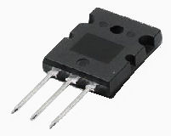

The field effect transistor is a three terminal device that is constructed with no PN-junctions within the main current carrying path between the Drain and the Source terminals, which correspond in function to the Collector and the Emitter respectively of the bipolar transistor. The current path between these two terminals is called the "channel" which may be made of either a P-type or an N-type semiconductor material. The control of current flowing in this channel is achieved by varying the voltage applied to the Gate. As their name implies, Bipolar Transistors are "Bipolar" devices because they operate with both types of charge carriers, Holes and Electrons. The Field Effect Transistor on the other hand is a "Unipolar" device that depends only on the conduction of electrons (N-channel) or holes (P-channel).
The Field Effect Transistor has one major advantage over its standard bipolar transistor cousins, in that their input impedance, (Rin ) is very high, (thousands of Ohms), while the BJT is comparatively low. This very high input impedance makes them very sensitive to input voltage signals, but the price of this high sensitivity also means that they can be easily damaged by static electricity. There are two main types of field effect transistor, the Junction Field Effect Transistor or JFET and the Insulated-gate Field Effect Transistor or IGFET), which is more commonly known as the standard Metal Oxide Semiconductor Field Effect Transistor MOSFET for short.
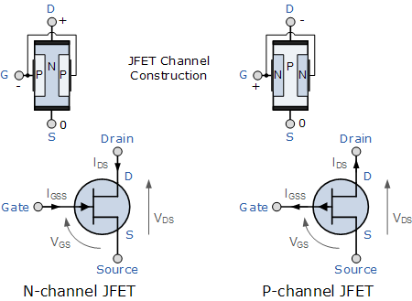

Junction Field Effect Transistor
We saw previously that a bipolar junction transistor is constructed using two PN-junctions in the main current carrying path between the Emitter and the Collector terminals. The Junction Field Effect Transistor (JUGFET or JFET) has no PN-junctions but instead has a narrow piece of high-resistivity semiconductor material forming a "Channel" of either N-type or P-type silicon for the majority carriers to flow through with two ohmic electrical connections at either end commonly called the Drain and the Source respectively.
There are two basic configurations of junction field effect transistor, the N-channel JFET and the P-channel JFET. The N-channel JFET's channel is doped with donor impurities meaning that the flow of current through the channel is negative (hence the term N-channel) in the form of electrons. Likewise, the P-channel JFET's channel is doped with acceptor impurities meaning that the flow of current through the channel is positive (hence the term P-channel) in the form of holes. N-channel JFET's have a greater channel conductivity (lower resistance) than their equivalent P-channel types, since electrons have a higher mobility through a conductor compared to holes. This makes the N-channel JFET's a more efficient conductor compared to their P-channel counterparts.
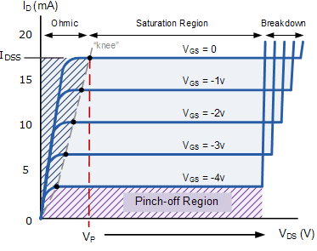

We have said previously that there are two ohmic electrical connections at either end of the channel called the Drain and the Source. But within this channel there is a third electrical connection which is called the Gate terminal and this can also be a P-type or N-type material forming a PN-junction with the main channel. The relationship between the connections of a junction field effect transistor and a bipolar junction transistor are compared below.

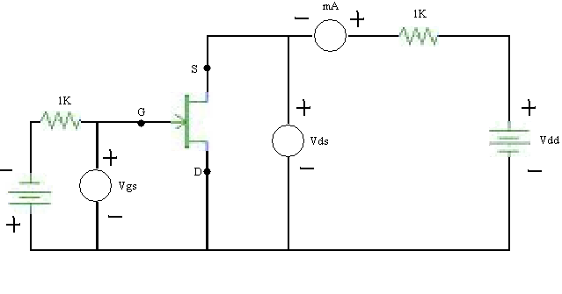
CIRCUIT DIAGRAM:

OBSERVATION TABLE:

Table-01
- Data for Drain Characteristics
SL NOS | V_{GS}=0V |  | V_{GS}=1V
SL NOS | I_{D} (mA) | V_{DS} (V) | I_{D} (mA) | V_{DS} (V)

Table-02
- Data for Transfer Characteristics
SL NOS | VDS=2.5
SL NOS | ID (mA) | Vgs (V)

CONCLUSION:

EXPERIMENT NO 8: Application of Operational Amplifier

OBJECTIVE:
To the study inverting amplifier, non inverting amplifier, adder, Subtractor, integrator and differentiator circuit using operational amplifier.

THEORY: The Non Inverting Op Amp:
The second basic configuration of an operational amplifier circuit is that of a Non-inverting Amplifier. In this configuration, the input voltage signal, (Vin) is applied directly to the non-inverting (+) input terminal which means that the output gain of the amplifier becomes "Positive" in value in contrast to the "Inverting Amplifier" circuit we saw in the last tutorial whose output gain is negative in value. The result of this is that the output signal is "in-phase" with the input signal.
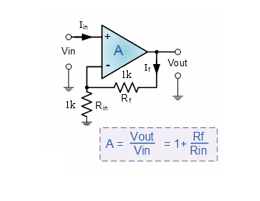

The Inverting Op Amp:
An inverting amplifier inverts and scales the input signal. As long as the op-amp gain is very large, the amplifier gain is determined by two stable external resistors (the feedback resistor R_{f} and the input resistor R_{in}) and not by op-amp parameters which are highly temperature dependent. In particular, the R_{in}–R_{f} resistor network acts as an electronic seesaw (i.e., a class-1 lever) where the inverting (i.e., −) input of the operational amplifier is like a fulcrum about which the seesaw pivots. That is, because the operational amplifier is in a negative-feedback configuration, its internal high gain effectively fixes the inverting (i.e., −) input at the same 0 V (ground) voltage of the non-inverting (i.e., +) input, which is similar to the stiff mechanical support provided by the fulcrum of the seesaw. Continuing the analogy,
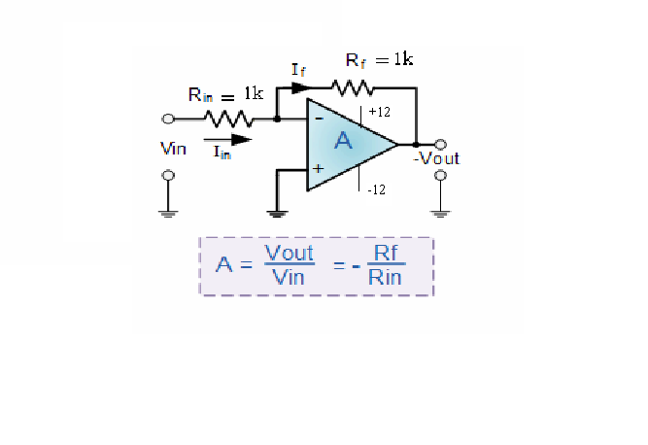

THE ADDER
The adder circuit can be made by connecting more inputs to the inverting op amp. The opposite end of the resistor connected to the inverting input is held at virtual ground by the feed back, therefore, adding new inputs does not effect the response of the existing inputs.
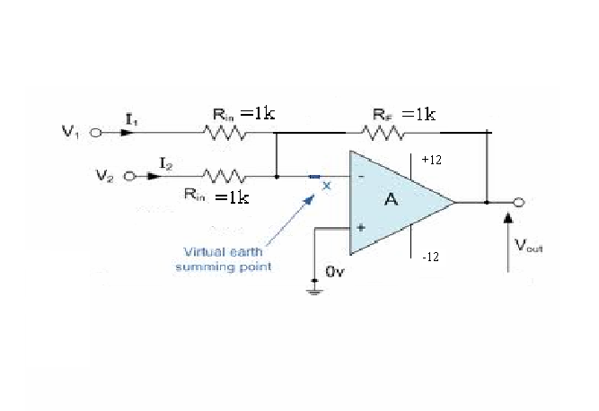
CIRCUIT DIAGRAM:

OBSERVATION TABLE:

- Non Inverting Op Amp
Theoretical value |  | Practical value
V_{IN} | V_{OUT} | V_{IN} | V_{OUT}

- Inverting Op Amp

Theoretical value |  | Practical value
V_{IN} | V_{OUT} | V_{IN} | V_{OUT}

- ADDER
Theoretical value |  |  | Practical value
V_{IN1} | V_{IN2} | V_{OUT} | V_{IN1} | V_{IN2} | V_{OUT}

CONCLUSION:

EXPERIMENT NO 9: Application of Sub tractor, Integrator and Differentiator
OBJECTIVE:
To the study Subtractor, integrator and differentiator circuit using operational amplifier

EQUIPMENTS REQUIRED:-
- Power supply
- Voltmeter
- Resistance
- Capacitor
- CRO
- Function generator
- Op Amp (741)

THEORY:
SUBTRACTOR:-
The circuit that takes the difference of two signals is called a Subtractor. It is made by connecting an inverting amplifier to a two-input inverting average.
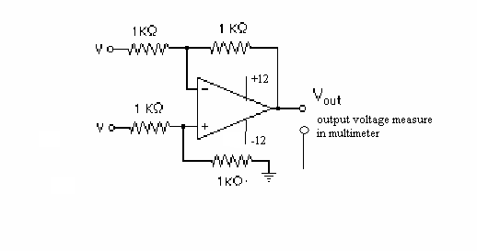

INTEGRATOR:-
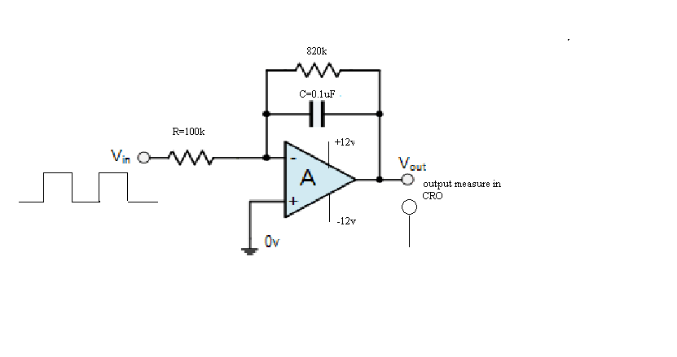
The integrator basically works like this: whatever current I you get flowing in R1, gets integrated across capacitor C1. The output voltage Vo is simply the voltage across C1. One great application of the integrator is generating a ramp voltage. You can do this by placing a fixed voltage at VS that forces a constant current through R1. The capacitor then integrates this current creating a ramping voltage. The action is just like a garden hose running water at a constant rate causing the level in a bucket to rise steadily. The smaller the diameter bucket (smaller capacitor), the faster the increase in water level (greater voltage). The switch is needed to discharge the capacitor (empty the bucket) at the end of a ramping cycle.

DIFFERENTIATOR:-
The basic Op-amp Differentiator circuit is the exact opposite to that of the Integrator operational amplifier circuit that we saw in the previous tutorial. Here, the position of the capacitor and resistor have been reversed and now the reactance, is connected to the input terminal of the inverting amplifier while the resistor, forms the negative feedback element across the operational amplifier as normal.
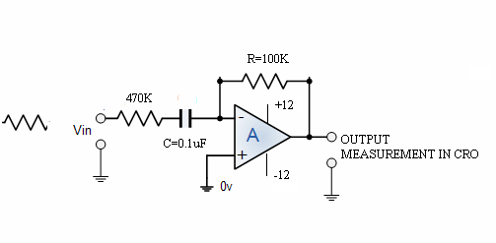
CIRCUIT DIAGRAM:

OBSERVATION TABLE:

- SUBTRACTOR

Theoretical value |  |  | Practical value
V_{IN1} | V_{IN2} | V_{OUT} | V_{IN1} | V_{IN2} | V_{OUT}

- INTEGRATOR

V_{IN} | INPUT  WAVEFORM | INPUT  FREQUENCY | V_{OUT} | OUTPUT  WAVEFORM | OUTPUT  FREQUENCY

- DIFFERENTIATOR

V_{IN} | INPUT  WAVEFORM | INPUT  FREQUENCY | V_{OUT} | OUTPUT  WAVEFORM | OUTPUT  FREQUENCY

CONCLUSION:

EXPERIMENT 10 – Determination Of Common Mode Rejection Ratio, Bandwidth And Slew Rate Of An Operational Amplifier

OBJECTIVE:
To measure common mode rejection ratio, bandwidth, slew rate of an op amp.

Theory:-
Common Mode Rejection Ratio (CMRR)
The common-mode rejection ratio (CMRR) of a differential amplifier (or other device) is the tendency of the devices to reject the input signals common to both input leads. A high CMRR is important in applications where the signal of interest is represented by a small voltage fluctuation superimposed on a (possibly large) voltage offset, or when relevant information is contained in the voltage difference between two signals.
CIRCUIT DIAGRAM:-
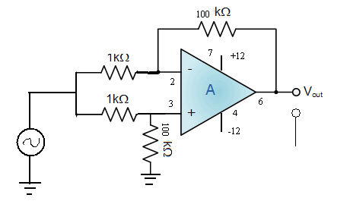

Working procedure:-
- Connect the circuit as shown in the figure.
- Give the sinusoidal input of 1 volt peak to peak 500 Hz.
- Switch ON the dual power supply.
- Note down the output voltage.
- Determine the CMRR using the following formula
Common mode gain (AC)=V_{OUT}/V_{IN}
Differential made gain (Ad)=R₂/R₁
CMRR=20log [Ad/Ac] in Db
- Repeat the experiment for 1KHz, 10KHz, 100KHz
Table-01
- Determination of common mode rejection ratio
Frequency | V_{IN} | V_{OUT} | Ac | Ad | (dB) CMRR

BANDWIDTH
The gain–bandwidth product for an amplifier is the product of the amplifier's bandwidth and the gain at which the bandwidth is measured. Operational amplifiers that are designed to have a simple one-pole frequency response, the gain–bandwidth product is nearly independent of the gain at which it is measured; in such devices the gain–bandwidth product will also be equal to the unity-gain bandwidth of the amplifier. For an amplifier in which negative feedback reduces the gain to below the open-loop gain, the gain–bandwidth product of the closed-loop amplifier will be approximately equal to that of the open-loop amplifier

CIRCUIT DIAGRAM:-
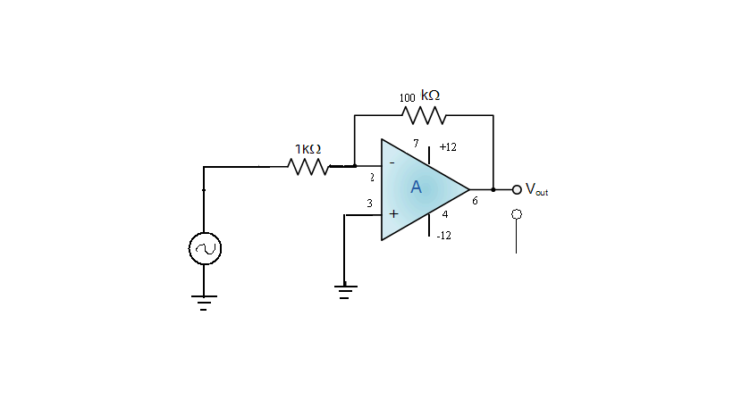

Working procedure:-
- Connect the circuit as shown in the figure.
- Give the sinusoidal input of 1 volt peak to peak.
- Switch ON the dual power supply
- Increase the frequency in suitable step and note down the corresponding out put voltage.
- Plot the frequency vs gain in graph then from the graph find the frequency, at which output voltage reduces to 0.7 times the output voltage, this gives the bandwidth of the op-amp at unity gain.

Table-02
- Determination of bandwidth of an op-amp
Input voltage (Vi) = V
SL NOS | FREQUENCY  IN KHz | OUTPUT VOLTAGE IN VOLT | VOLTAGE GAIN (V_{O}/V_{I}) | BANDWIDTH FROM GRAPH

Plot frequency vs voltage gain in a graph.

SLEW RATE
The slew rate of an electronic circuit is defined as the maximum rate of change of the output voltage. Slew rate is usually expressed in units of V/µs.
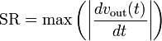
Where is the output produced by the amplifier as a function of time t. Limitations in slew rate capability can give rise to non linear effects in electronic amplifiers. For a sinusoidal waveform not to be subject to slew rate limitation, the slew rate capability (in volts per second) at all points in an amplifier must satisfy the following condition:
Where f is the operating frequency, and is the peak amplitude of the waveform. In mechanics the slew rate is given in dimensions 1/T and is associated with the change in position over time of an object which orbits around the observer.

CIRCUIT DIAGRAM:-
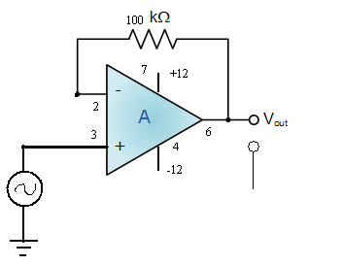

Working procedure:-
- Connect the circuit as shown in the figure.
- Give the sinusoidal input of 1 volt peak to peak 1KHz
- Switch ON the dual power supply
- Note the change of output voltage (ΔVo) and change of time for the rising and falling slop (Δt)
- Vary the input frequency in suitable steps and note ΔVo and Δ t
- Find the slew rate (SR: ΔVo/Δt) for different frequency

SL NO | FREQUENCY | CHANGE OF OUTPIT VOLTAGE (ΔVo) | CHANGE OF TIME(Δt) for rising slope | CHANGE OF TIME(Δt) for falling slope | MEAN (Δt) | SLEW RATE  ΔVo/Δt  IN v/µs

CONCLUSION:

